REVIEW FOR DAVE SHARP’S SECRET SEVEN CD “7” on Blue Pie Records
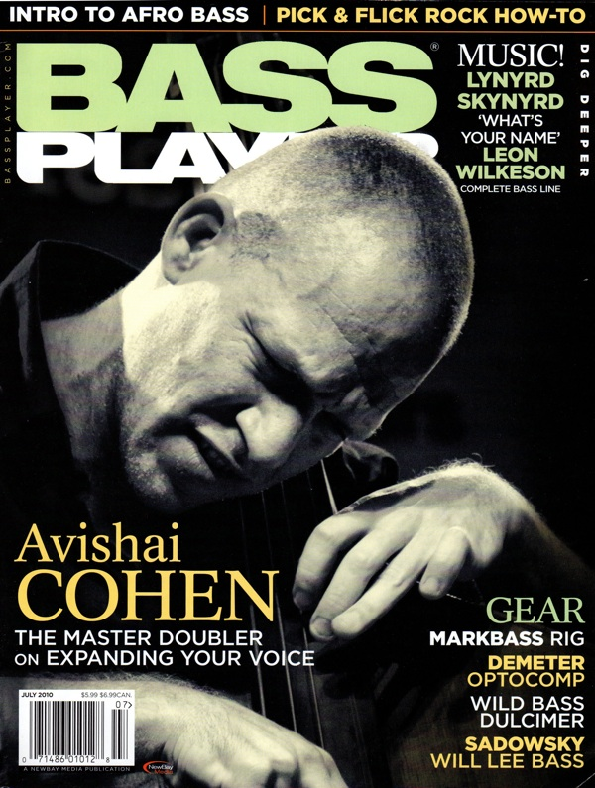
Track listing: Africano; Chrispy Underground; Skeleton Key; Blackout; Boop Bwee Ahh; The Seventh Secret; Lootmar (Wind Song); Africano [Radio Edit]; Can I Be Your Squeeze?
From BASS PLAYER MAGAZINE
JULY 2010 ISSUE
Dave Sharp’s Secret Seven
7 [Vortex Jazz 1969]
Ann Arbor, Michigan doubler Dave Sharp stays sharp on this recorded debut of his band Secret Seven. He’s a serious groover, as the lilting Afrobeat “Africano” demonstrates, but the record’s diverse stylistic palette shows off a kaleidoscopic competency in a wide array of styles. The record’s lush production is a bonus, giving it an airiness and clarity that suits the at-times dense material. -Jonathan Herrera

